Electric Forces, Fields, and Potential
DEMOCRITUS, A GREEK PHILOSOPHER OF the 5th century B.C., was the first to propose that all things are made of indivisible particles called atoms. His hypothesis was only half right. The things we call atoms today are in fact made up of three different kinds of particles: protons, neutrons, and electrons. Electrons are much smaller than the other two particles. Under the influence of the electronic force, electrons orbit the nucleus of the atom, which contains protons and neutrons.
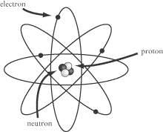
Protons and electrons both carry electric charge, which causes them to be attracted to one another. In most atoms, there are as many electrons as there are protons, and the opposite charges of these two kinds of particle balance out. However, it is possible to break electrons free from their orbits about the nucleus, causing an imbalance in charge. The movement of free electrons is the source of everything that we associate with electricity, a phenomenon whose power we have learned to harness over the past few hundred years to revolutionary effect.

Electric Charge
It is very difficult, if not impossible, to understand fully what electric charge, q, is. For SAT II Physics, you need only remember the old phrase: opposites attract. Protons carry a positive charge and electrons carry a negative charge, so you can just remember these three simple rules:
- Two positive charges will repel one another.
- Two negative charges will repel one another.
- A positive charge and a negative charge will attract one another.
The amount of positive charge in a proton is equal to the amount of negative charge in an electron, so an atom with an equal number of protons and electrons is electrically neutral, since the positive and negative charges balance out. Our focus will be on those cases when electrons are liberated from their atoms so that the atom is left with a net positive charge and the electron carries a net negative charge somewhere else.
Conservation of Charge
The SI unit of charge is the coulomb (C). The smallest unit of charge, e—the charge carried by a proton or an electron—is approximately C. The conservation of charge—a hypothesis first put forward by Benjamin Franklin—tells us that charge can be neither created nor destroyed. The conservation of charge is much like the conservation of energy: the net charge in the universe is a constant, but charge, like energy, can be transferred from one place to another, so that a given system experiences a net gain or loss of charge. Two common examples of charge being transferred from one place to another are:
- Rubbing a rubber rod with a piece of wool: The rod will pull the electrons off the wool, so that the rubber rod will end up with a net negative charge and the wool will have a net positive charge. You’ve probably experienced the “shocking” effects of rubbing rubber-soled shoes on a wool carpet.
- Rubbing a glass rod with a piece of silk: The silk will pull the electrons off the glass, so that the glass rod will end up with a net positive charge and the silk will have a net negative charge.
Remember, net charge is always conserved: the positive charge of the wool or glass rod will balance out the negative charge of the rubber rod or silk.
The Electroscope
The electroscope is a device commonly used—and sometimes included on SAT II Physics—to demonstrate how electric charge works. It consists of a metal bulb connected to a rod, which in turn is connected to two thin leaves of metal contained within an evacuated glass chamber. When a negatively charged object is brought close to the metal bulb, the electrons in the bulb are repelled by the charge in the object and move down the rod to the two thin leaves. As a result, the bulb at the top takes on a positive charge and the two leaves take on a negative charge. The two metal leaves then push apart, as they are both negatively charged, and repel one another.
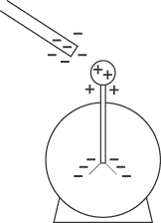
When a positively charged object approaches the metal bulb, the exact opposite happens, but with the same result. Electrons are drawn up toward the bulb, so that the bulb takes on a negative charge and the metal leaves have a positive charge. Because both leaves still have the same charge, they will still push apart.

Electric Force
There is a certain force associated with electric charge, so when a net charge is produced, a net electric force is also produced. We find electric force at work in anything that runs on batteries or uses a plug, but that isn’t all. Almost all the forces we examine in this book come from electric charges. When two objects “touch” one another—be it in a car crash or a handshake—the atoms of the two objects never actually come into contact. Rather, the atoms in the two objects repel each other by means of an electric force.
Coulomb’s Law
Electric force is analogous to gravitational force: the attraction or repulsion between two particles is directly proportional to the charge of the two particles and inversely proportional to the square of the distance between them. This relation is expressed mathematically as Coulomb’s Law:
In this equation, and are the charges of the two particles, r is the distance between them, and k is a constant of proportionality. In a vacuum, this constant is Coulumb’s constant, , which is approximately N · m2 / C2. Coulomb’s constant is often expressed in terms of a more fundamental constant—the permittivity of free space, , which has a value of C2/ N · m2:
If they come up on SAT II Physics, the values for and will be given to you, as will any other values for k when the electric force is acting in some other medium.
EXAMPLE
Two particles, one with charge +q and the other with charge –q, are a distance r apart. If the distance between the two particles is doubled and the charge of one of the particles is doubled, how does the electric force between them change?

According to Coulomb’s Law, the electric force between the two particles is initially
If we double one of the charges and double the value of r, we find:

Doubling the charge on one of the particles doubles the electric force, but doubling the distance between the particles divides the force by four, so in all, the electric force is half as strong as before.
Superposition
If you’ve got the hang of vectors, then you shouldn’t have too much trouble with the law of superposition of electric forces. The net force acting on a charged particle is the vector sum of all the forces acting on it. For instance, suppose we have a number of charged particles, , , and . The net force acting on is the force exerted on it by added to the force exerted on it by . More generally, in a system of n particles:
where is the force exerted on particle 1 by particle n and is the net force acting on particle 1. The particle in the center of the triangle in the diagram below has no net force acting upon it, because the forces exerted by the three other particles cancel each other out.
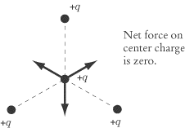
EXAMPLE
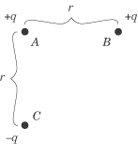
In the figure above, what is the direction of the force acting on particle A?

The net force acting on A is the vector sum of the force of B acting on A and the force of C acting on A. Because they are both positive charges, the force between A and B is repulsive, and the force of B on A will act to push A toward the left of the page. C will have an attractive force on A and will pull it toward the bottom of the page. If we add the effects of these two forces together, we find that the net force acting on A is diagonally down and to the left.
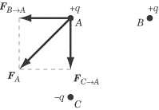

Electric Field
An electric charge, q, can exert its force on other charged objects even though they are some distance away. Every charge has an electric field associated with it, which exerts an electric force over all charges within that field. We can represent an electric field graphically by drawing vectors representing the force that would act upon a positive point charge placed at that location. That means a positive charge placed anywhere in an electric field will move in the direction of the electric field lines, while a negative charge will move in the opposite direction of the electric field lines. The density of the resulting electric field lines represents the strength of the electric field at any particular point.
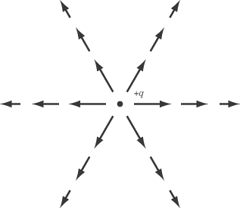
Calculating Electric Field
The electric field is a vector field: at each point in space, there is a vector corresponding to the electric field. The force F experienced by a particle q in electric field E is:
Combining this equation with Coulomb’s Law, we can also calculate the magnitude of the electric field created by a charge q at any point in space. Simply substitute Coulomb’s Law in for , and you get:
Drawing Electric Field Lines
SAT II Physics may ask a question about electric fields that involves the graphical representation of electric field lines. We saw above how the field lines of a single point charge are represented. Let’s now take a look at a couple of more complicated cases.
Electric Fields for Multiple Charges
Just like the force due to electric charges, the electric field created by multiple charges is the sum of the electric fields of each charge. For example, we can sketch the electric field due to two charges, one positive and one negative:
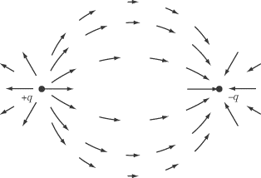
Line Charges and Plane Charges
Suppose we had a line of charge, rather than just a point charge. The electric field strength then decreases linearly with distance, rather than as the square of the distance. For a plane of charge, the field is constant with distance.
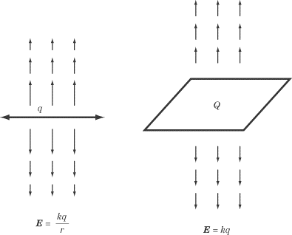

Electric Potential
Because the electric force can displace charged objects, it is capable of doing work. The presence of an electric field implies the potential for work to be done on a charged object. By studying the electric potential between two points in an electric field, we can learn a great deal about the work and energy associated with electric force.
Electric Potential Energy
Because an electric field exerts a force on any charge in that field, and because that force causes charges to move a certain distance, we can say that an electric field does work on charges. Consequently, we can say that a charge in an electric field has a certain amount of potential energy, U. Just as we saw in the chapter on work, energy, and power, the potential energy of a charge decreases as work is done on it:
Work
The work done to move a charge is the force, F, exerted on the charge, multiplied by the displacement, d, of the charge in the direction of the force. As we saw earlier, the magnitude of the force exerted on a charge q in an electric field E is = qE. Thus, we can derive the following equation for the work done on a charge:
Remember that d is not simply the displacement; it is the displacement in the direction that the force is exerted. When thinking about work and electric fields, keep these three rules in mind:
- When the charge moves a distance r parallel to the electric field lines, the work done is qEr.
- When the charge moves a distance r perpendicular to the electric field lines, no work is done.
- When the charge moves a distance r at an angle to the electric field lines, the work done is qEr cos .
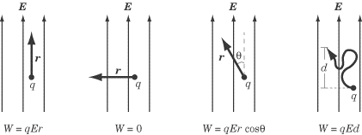
EXAMPLE
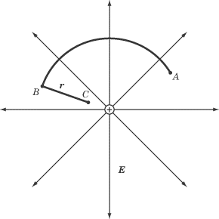
In an electric field, E, a positive charge, q, is moved in the circular path described above, from point A to point B, and then in a straight line of distance r toward the source of the electric field, from point B to point C. How much work is done by the electric field on the charge? If the charge were then made to return in a straight line from point C to point A, how much work would be done?

HOW MUCH WORK IS DONE MOVING THE CHARGE FROM POINT A TO POINT B TO POINT C ?
The path from point A to point B is perpendicular to the radial electric field throughout, so no work is done. Moving the charge from point B to point C requires a certain amount of work to be done against the electric field, since the positive charge is moving against its natural tendency to move in the direction of the electric field lines. The amount of work done is:
The negative sign in the equation reflects the fact that work was done against the electric field.
HOW MUCH WORK IS DONE MOVING THE CHARGE DIRECTLY FROM POINT C BACK TO POINT A?
The electric force is a conservative force, meaning that the path taken from one point in the electric field to another is irrelevant. The charge could move in a straight line from point C to point A or in a complex series of zigzags: either way, the amount of work done by the electric field on the charge would be the same. The only thing that affects the amount of work done is the displacement of the charge in the direction of the electric field lines. Because we are simply moving the charge back to where it started, the amount of work done is W = qEr.
Potential Difference
Much like gravitational potential energy, there is no absolute, objective point of reference from which to measure electric potential energy. Fortunately, we are generally not interested in an absolute measure, but rather in the electric potential, or potential difference, V, between two points. For instance, the voltage reading on a battery tells us the difference in potential energy between the positive end and the negative end of the battery, which in turn tells us the amount of energy that can be generated by allowing electrons to flow from the negative end to the positive end. We’ll look at batteries in more detail in the chapter on circuits.
Potential difference is a measure of work per unit charge, and is measured in units of joules per coulomb, or volts (V). One volt is equal to one joule per coulomb.
Potential difference plays an important role in electric circuits, and we will look at it more closely in the next chapter.

Conductors and Insulators
Idealized point charges and constant electric fields may be exciting, but, you may ask, what about the real world? Well, in some materials, such as copper, platinum, and most other metals, the electrons are only loosely bound to the nucleus and are quite free to flow, while in others, such as wood and rubber, the electrons are quite tightly bound to the nucleus and cannot flow. We call the first sort of materials conductorsand the second insulators. The behavior of materials in between these extremes, called semiconductors, is more complicated. Such materials, like silicon and germanium, are the basis of all computer chips.
In a conductor, vast numbers of electrons can flow freely. If a number of electrons are transmitted to a conductor, they will quickly distribute themselves across the conductor so that the forces between them cancel each other out. As a result, the electric field within a conductor will be zero. For instance, in the case of a metal sphere, electrons will distribute themselves evenly so that there is a charge on the surface of the sphere, not within the sphere.

Key Formulas
Coulomb’s Law
The Law of Superposition
Definition of the Electric Field
Electric Potential Energy
Work Done by an Electric Field
Electric Potential

Practice Questions
1. | When a long-haired woman puts her hands on a Van de Graaff generator—a large conducting sphere with charge being delivered to it by a conveyer belt—her hair stands on end. Which of the following explains this phenomenon?
 | (A) | Like charges attract
 | (B) | Like charges repel
 | (C) | Her hair will not stand on end
 | (D) | Her body is conducting a current to the ground
 | (E) | The Van de Graaf generator makes a magnetic field that draws her hair up on end

 | 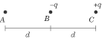
2. | Three particles, A, B, and C, are set in a line, with a distance of d between each of them, as shown above. If particle B is attracted to particle A, what can we say about the charge, , of particle A?
 | (A) | < –q
 | (B) | –q < < 0
 | (C) | = 0
 | (D) | 0 < < +q
 | (E) | > +q

3. | A particle of charge +2q exerts a force F on a particle of charge –q. What is the force exerted by the particle of charge –q on the particle of charge +2q?
 | (A) | 1/2 F
 | (B) | 0
 | (C) | 2F
 | (D) | F
 | (E) | –F

4. | Two charged particles exert a force of magnitude F on one another. If the distance between them is doubled and the charge of one of the particles is doubled, what is the new force acting between them?
 | (A) | 1/4 F
 | (B) | 1/2 F
 | (C) | F
 | (D) | 2F
 | (E) | 4F

 | 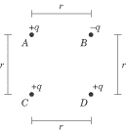
5. | Four charged particles are arranged in a square, as shown above. What is the direction of the force acting on particle A?



 | (A)
 | (B)
 | (C)
 | (D)
 | (E)

6. | Two identical positive charges of +Q are 1 m apart. What is the magnitude and direction of the electric field at point A, 0.25 m to the right of the left-hand charge?
 | (A) | 3/4 kQ to the right
 | (B) | 128/9 kQ to the left
 | (C) | 160/9 kQ to the left
 | (D) | 160/9 kQ to the right
 | (E) | 128/9 kQ to the right

7. | A particle of charge +q is a distance r away from a charged flat surface and experiences a force of magnitude F pulling it toward the surface. What is the magnitude of the force exerted on a particle of charge +q that is a distance 2r from the surface?
 | (A) | 1/8 F
 | (B) | 1/4 F
 | (C) | 1/2 F
 | (D) | F
 | (E) | 2F

8. | What is the change in potential energy of a particle of charge +q that is brought from a distance of 3r to a distance of 2r by a particle of charge –q?
 | (A)
 | (B)
 | (C)
 | (D)
 | (E)

9. | Two charges are separated by a distance d. If the distance between them is doubled, how does the electric potential between them change?
 | (A) | It is doubled
 | (B) | It is halved
 | (C) | It is quartered
 | (D) | It is quadrupled
 | (E) | It is unchanged

10. | A solid copper sphere has a charge of +Q on it. Where on the sphere does the charge reside?
 | (A) | +Q at the center of the sphere
 | (B) | Q/2 at the center of the sphere and Q/2 on the outer surface
 | (C) | –Q at the center of the sphere and +2Q on the outer surface
 | (D) | +Q on the outer surface
 | (E) | The charge is spread evenly throughout the sphere

Explanations
1. B
Charge (either positive or negative) is brought to the woman by the Van de Graaf generator. This charge then migrates to the ends of her hair. The repulsive force between like charges makes the hair separate and stand on end. A violates Columbs Law. D and E do not explain the phenomenon.
2. E
Particle C exerts an attractive force on the negatively charged particle B. If B is to be pulled in the direction of A, A must exert an even stronger attractive force than particle C. That means that particle A must have a stronger positive charge than particle C, which is +q.
3. E
The electric force exerted by one charged particle on another is proportional to the charge on both particles. That is, the force exerted by the +2q particle on the –q particle is of the same magnitude as the force exerted by the –q particle on the +2q particle, because, according to Coulomb’s Law, both forces have a magnitude of:
Since one particle is positive and the other is negative, this force is attractive: each particle is pulled toward the other. Since the two particles are pulled toward each other, the forces must be acting in opposite directions. If one particle experiences a force of F, then the other particle must experience a force of –F.
4. B
Coulomb’s Law tells us that : the force between two particles is directly proportional to their charges and inversely proportional to the square of the distance between them. If the charge of one of the particles is doubled, then the force is doubled. If the distance between them is doubled, then the force is divided by four. Since the force is multiplied by two and divided by four, the net effect is that the force is halved.
5. C
Particles C and D exert a repulsive force on A, while B exerts an attractive force. The force exerted by D is somewhat less than the other two, because it is farther away. The resulting forces are diagrammed below:
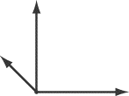
The vector sum of the three vectors will point diagonally up and to the right, as does the vector in C.
6. E
The vector for electric field strength at any point has a magnitude of and points in the direction that a positive point charge would move if it were at that location. Because there are two different point charges, and , there are two different electric fields acting at point A. The net electric field at A will be the vector sum of those two fields. We can calculate the magnitude of the electric field of each charge respectively:

Since both and would exert a repulsive force on a positive point charge, points to the right and points to the left. The net electric field is:
Because is closer to A than , the electric field from will be stronger than the electric field from , and so the net electric field will point to the right.
7. D
The charged surface is a plane charge, and the electric field exerted by a plane charge is E = kq. That is, the magnitude of the electric field strength does not vary with distance, so a particle of charge +q will experience the same attractive force toward the charged surface no matter how far away it is.
8. B
The change in potential energy of a point particle, with reference to infinity is given by:

The difference in potential energy between two points is given by:

9. B
The electric potential of a charge is given by the equation V = kq/r. In other words, distance is inversely proportional to electric potential. If the distance is doubled, then the electric potential must be halved.
10. D
Excess charges always reside on the surface of a conductor because they are free to move, and feel a repulsive force from each other.

